RESUME

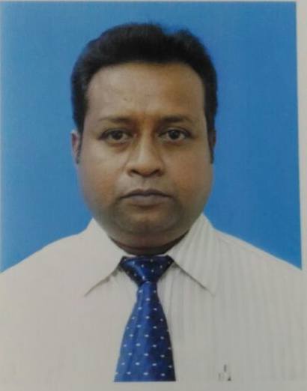
ABHIJIT KUMAR SARKAR

“SONARTORI APPTS”
Flat No. C-3,2nd Floor,
154/1,Gostotala Road,
Kamdahari, Garia,
Kolkata-700084

CAREER OBJECTIVE

A proactive professional seeking a challenging position in an environment, making an important contribution towards financial health and strategy of the growing company and to work in an atmosphere conductive to the free flow of ideas. I believe in successfully applying my skills, knowledge and experience for the growth of the company and for achieving my personal goals.

WORKING EXPERIENCE
1.Presently working with “BTL- AGRO- LTD” a division of “SHRACHI” group working from April-17, as “Area Manager-Sales” responsible for their “Tractor Driven Agriculture Equipments” sales for entire WB.

2.Worked with “Sonalika Agro Industries” (from April’16 to April’17) it is a wing of famous “Sonalika Group”.Woking in a capacity of “Manager” sales & marketing.Responsiable for entire West Bengal & North East market for our entire farm equipment product.

3. Worked with “India Pistons Ltd” (from Dec’14 to Dec’15) it is a famous “Amalgamation Group”.Worked in a capacity of “Manager” sales & marketing.Looking after entire Odisha Market based at Cuttack.

4.Worked 1year 6 months (from June’13 to Nov’15) with “International Tractors Ltd”.As “Asst.Manager” based at Calcutta.It is a famous “Sonalika” group of companies.Responsiable for Spare Parts sale of “Sonalika Tractors” for entire W.Bengal and Assam.

5.Worked 10 years (2003 -2013) as a Area Manager with Perfect Circle (India) Ltd and Victor Gaskets (India) Ltd.H.Q at Kolkata looking after entire West Bengal.This is a famous “ANAND GROUP” company having a leadership in auto ancillary segment in OEM , After market and Export.

6.Worked five years (1998-2003) with Escorts Mahle Ltd. & Goetze India Ltd.Presently known as “Federal Mogul Goetze India Ltd”.
Two years from Jan 1998 to Dec 2000 based at Nashik (Maharashtra), looking for entire North Maharashtra as a Sales Officer.
Three years from Jan 2001 to Oct 2003 based at Kolkata looking for entire North Bengal and Kolkata market as a Sales Officer.

7.Worked two years (1996-1998) with Shriram Automotive Products Ltd. Based at Kolkata as Sr. Sales Representative.

8.Worked four years (1992-1996) with Escorts Ltd. (Auotmotive Divn) marketing as M.S.R at kolkata.

9.Worked one year (1991-1992) with Singer Sewing Machine Company. as a Sales Trainee.

JOB PROFILE

- Providing an environment for supportive inter-personal with top management.
- Substantial increase of retail counter and continuous stress on promotional activities to increase sales volume in my assigned territory.
- Establishing direct network as well as exploring distributor network.
- Distributor/Dealer network development.
- Promoting sales through distributor/dealer network.
- Providing training to dealer & distributors staff.
- Independent responsibility of handling assigned territories operation.
- Planning & strategy for handling seasonal product business.
- Planning for innovative sales promotion scheme.
- Interaction with distributors & dealers for primary& secondary sales according to the market requirements from time to time, collect orders form distributors & dealers. Prepared quarterly target of distributors & dealers & incentives schemes on target achievement. Prepared monthly indents and sales plan.
- Implementation of companies sales promotion in my given territory. Co-ordination with customers & dealers for warranty claims. Feedback to H.O on competitors activity and their schemes being announced in the trade from time to time.
- Achieving sales & collection targets.
ACADEMIC QUALIFIACATION
Passed B.com from The University of Calcutta in the year 1989.

KEY STRENGTHS
- Systematic & self motivated approach to work
- Self starter
- Team building abilities .
- Strong interpersonal & management skill.
- Strong analytical skills with an ability to reach a win win solution .
- High degree of adaptability to adjust to new environment.

PERSONAL PROFILE

Father’s Name : Late Hari pada Sarkar

Date of Birth : 15Th May 1968

Marital Status : Married

Nationality : Indian

Religion : Hindu

Sex : Male

Languages Known : English, Hindi , Bengali

Contact Nos : 09331215137, 09831706630

Email ID : asarkar1505@gmail.com

Expected Salary : Negotiable.

Present CTC : 6.20 Lakhs

Date :05.09.17

Place: KOLKATA ABHIJIT KUMAR SARKAR

